**Name:** M. Miller

**Date:** 2023-02-23

**Course:** IT_FDN_130_A_Wi_23_Foundations_of_Databases_and_SQL_Programming

**GitHub Link**: <https://github.com/uw204773/A06_MMiller>

**Assignment 07 – Funcitons**

# Introduction

In the assignment 07 document you asked us to:

1. Explain when you would use a SQL UDF.
2. Explain are the differences between Scalar, Inline, and Multi-Statement Functions.

# Topic

## SQL User-Defined Functions

Whether made as a temporary function, or a persistent one, a user-defined functions are routines that accept parameters listed, perform actions on the values input, and returns only the defined or altered results.

They can improve script execution time, lower server traffic, and can modular where it is created once and can be used by any user.

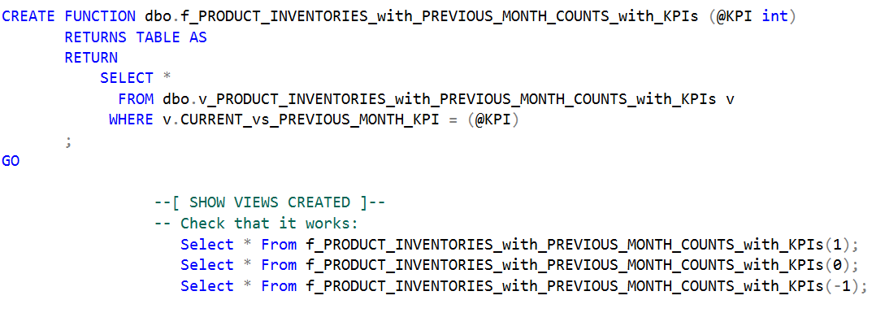

## Scalar

Scalar functions are ones that return a single value.

An example of a scalar value would be to take an amount, deduct an amount, and return the remainder for each record requested.

The however cannot return text or timestamps. To return a date value you’ll need to cast or convert the data.

## Inline

An inline function is a table-valued function. This kind of function takes one input parameter – text or integer – and returns columns from multiple sources and any aggregates for each.

## Multi-Statement Functions

A multi-statement function can call, using multiple statements, multiple columns of data, and those returned columns construct its own table that can be defined by the user.

# Summary

Functions can be used against views or tables, but are safer used against views with schemabinding. Functions can play a small or large role in a script written – jobs, procedures, etc. They save time and resources.